NEAPOLIS
Electric oven for pizzeria

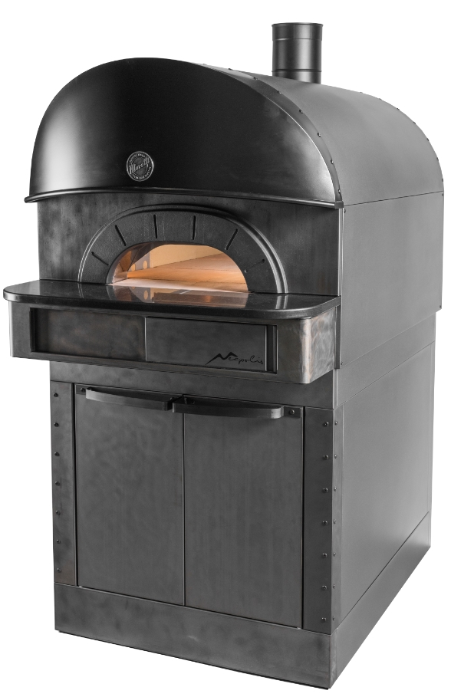
EXTERNAL CONSTRUCTION
- Sheet steel structure coated with high-temperature epoxy powder paint finish
- External panelling with "post-industrial" finish
- “Inox Fossile” coated front panel
- Black granite landing with slot for thermal bridge break
- Cast-iron oven opening
- Rounded fume hood with Neapolis® design
- Black coated stainless steel cylindrical flue
- Front-facing digital control panel and retractable sliding panel

INTERNAL CONSTRUCTION
- Oven chamber made from refractory material
- 5.5cm thick slab with interchangeable 'Biscuit' cooking surface positioned on top of heating plate made from perforated refractory material
- Resistors inserted inside the ceiling and floor perforated refractors
- High-density dual insulation for high temperatures
- Insulation with heated joints and a COOL AROUND® TECHNOLOGY air space

FUNCTIONING
- Heating via bare-wire coil resistors with optimised temperature balancing
- Maximum temperature of 510°C
- Self-stabilising internal deflectors situated on dome oven chamber surface to minimise leakage and ensure uniform heat distribution
- Electronic temperature management with independent adjustment of ceiling and floor
- Continuous temperature monitoring with thermocouple
- Steam draught adjustable via a manual valve

STANDARD EQUIPMENT
- Removable oven chamber stainless-steel door, with increased insulation and heat-resistant handle
- Stainless-steel door supports
- Protected lighting thanks to hidden double halogen lamps
- Lateral refractory protection in oven chamber opening
- Daily power-on timer
- ECO-STAND BY TECHNOLOGY® for work breaks
- 20 customisable programs
- Pre-set programs: temperature rises, average setting, maximum setting, heat-regulation cleaning
- Separate max. temperature safety device

MORETTI FORNI S.P.A.
OPTIONS AND ACCESSORIES
(WITH SURCHARGE)
- Unheated prover with hidden controllable castor wheels
- Heat-regulated prover with internal lighting and hidden controllable castor wheels
- Additional tray holder slides for prover

- Heavy Duty Pack
www.morettiforni.com info@morettiforni.com
Via A.Meucci, 4 - 61037 Mondolfo (PU) ITALIA Tel. +39.0721.96161 - Fax +39.0721.9616299

NEAPOLIS
11/17

(assembled with Leavening prover height 1050mm)

TOP VIEW REAR VIEW RIGHT SIDE VIEW
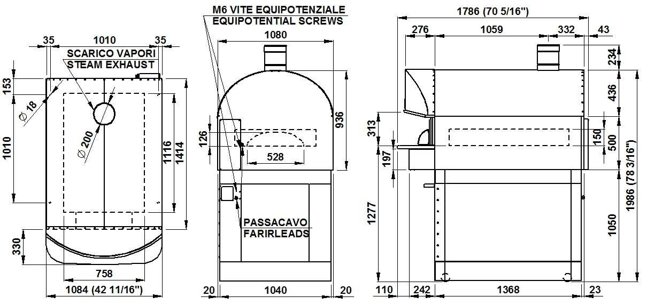
Please note: The dimensions shown in these diagrams are in millimetres.

SPECIFICATIONS
The appliance comprises one cooking element and an optional leavening prover. The oven’s cooking surface is made from "Biscuit" material, allowing for perfect heat distribution across, making this oven particularly suitable for Neapolitan-style pizzas. Temperature regulation is electronic, the ceiling and floor bare-wire coil resistors can be independently controlled. The oven is equipped with a removable door for high-insulation closure. The maximum temperature of the baking chamber is 510°C. The prover consists of a coated steel structure, equipped with hidden controllable castor wheels. The prover’s maximum temperature on the heat-regulated model is 65°C.

All the data provided below refers to the configuration with 1 baking chamber

DIMENSIONS
SHIPPING INFORMATION
FEEDING AND POWER

External height External depth External width | 936mm 1786mm 1084mm | Packed in wooden crate Height  Depth | 1090mm 1940mm | Standard feeding  A.C. V400 3N  Feeding on request
Weight | 385kg | Width | 1200mm | A.C. V230 3
Baking surface | 0,84m2 | Weight | (385+70)kg | Frequency | 50/60Hz
 |  |  |  | Max power | 12,9kW
TOTAL BAKING CAPACITY |  | When combined with | leavening | *Average power cons | 7,5kWh
 |  | prover: |  | Connecting cable

Pizza diameter 330mm 6
Max height 2200mm
Max weight (510+100)kg

type H07RN-F 5x4mm2 (V400 3N)
4x10mm2 (V230 3)

Heat-regulated power supply
A.C. V230 1N 50/60 Hz
Max power 1,5kW
*Average power cons 0,8kWh Connecting cable type H07RN-F 3x1,5mm2

