SKIPIO GELATO CASE MAINTENANCE MANUAL

Models: SGC-1200F, SGF-1500F, SGC-1800F
Greetings! Below are the few maintenance things that need to be done regularly to keep your gelato case in good condition.

- Cleaning the condenser
Please remove the back panel at the bottom of the unit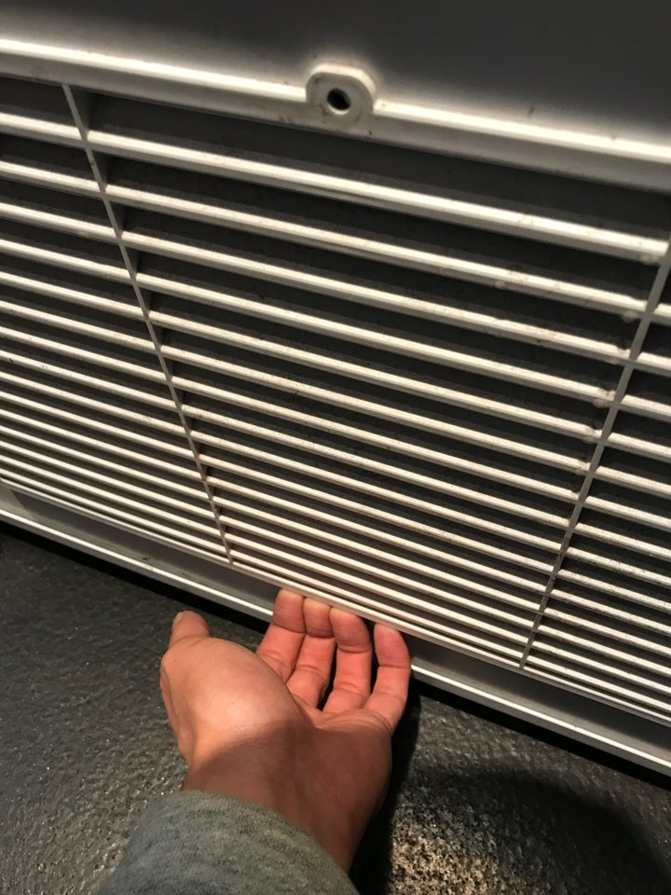

Using the brush supplied, please clean the condenser area and remove all dust. This is recommended every 2 weeks. Not keeping this area clean regularly may result in a void of warranty.
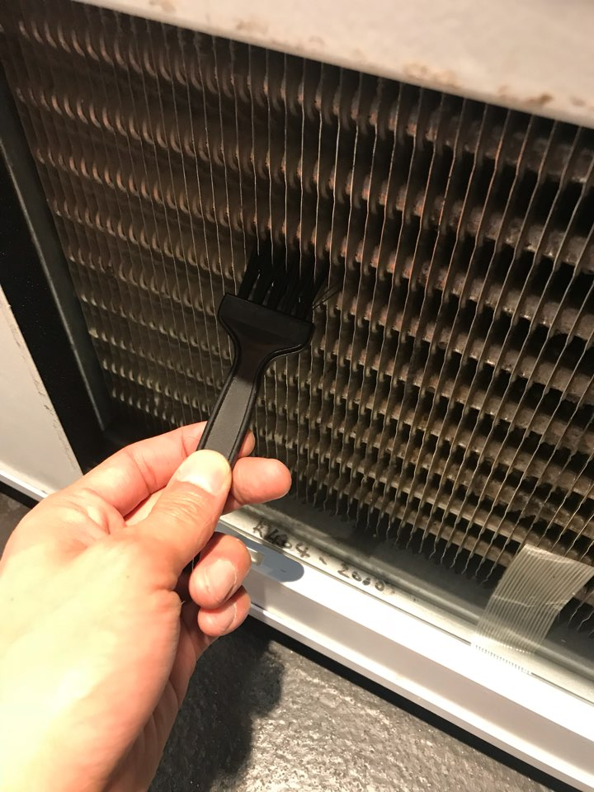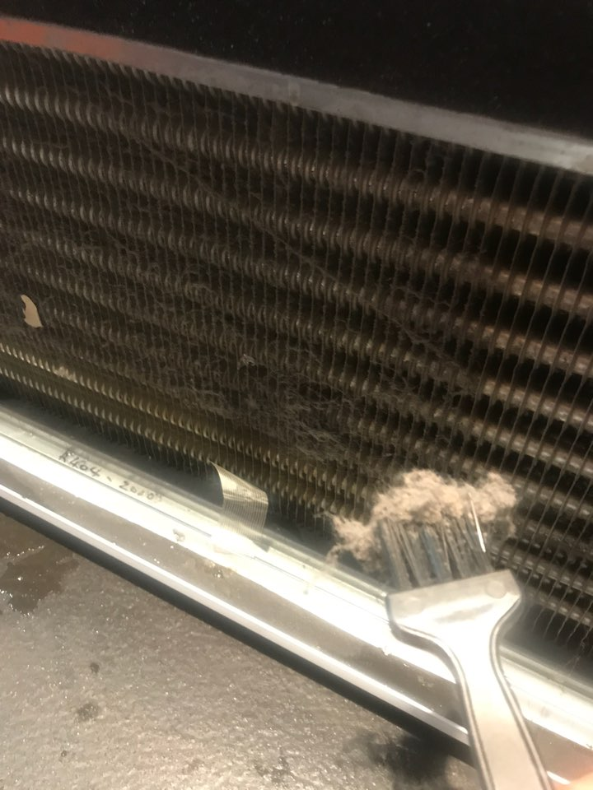

- Cleaning the inside of the unit.
It is recommended to clean the inside of the gelato case every 2 weeks with the gelato and pans removed. Not cleaning inside may result in the drain hose being blocked, which will affect performance. Any issues caused by not cleaning this area will void warranty.

- Evaporator Maintenance
When cleaning the unit as above, it is required to also turn off the unit overnight to prevent the evaporators from being frozen. This is recommended every time you clean inside the unit.
For best performance, once every week.
Minimum, once every month.
This will void warranty, if not maintained.
Below photo is an evaporator frozen from no maintenance.

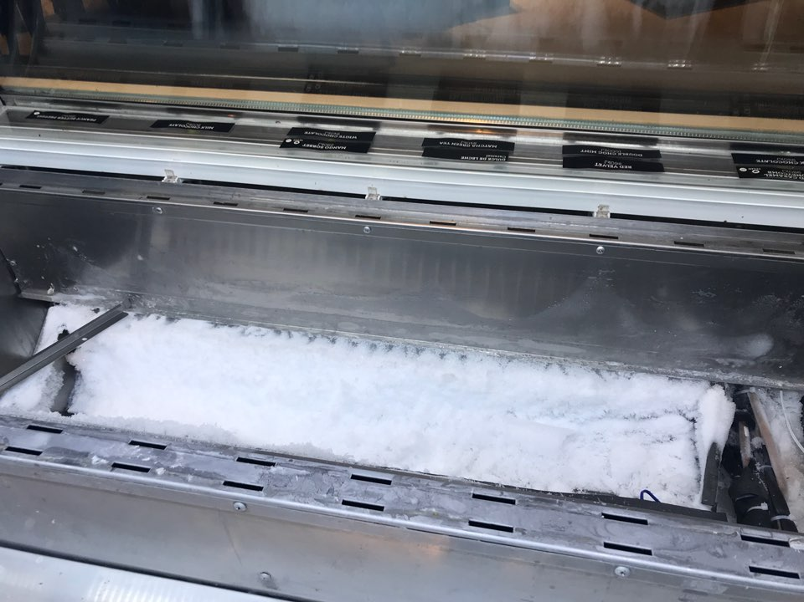

- Keeping the sliding doors closed when not in use.
It is recommended to keep the sliding doors closed when not in use. Keeping the doors open for long intervals will see condensation forming inside and affecting temperature performance.
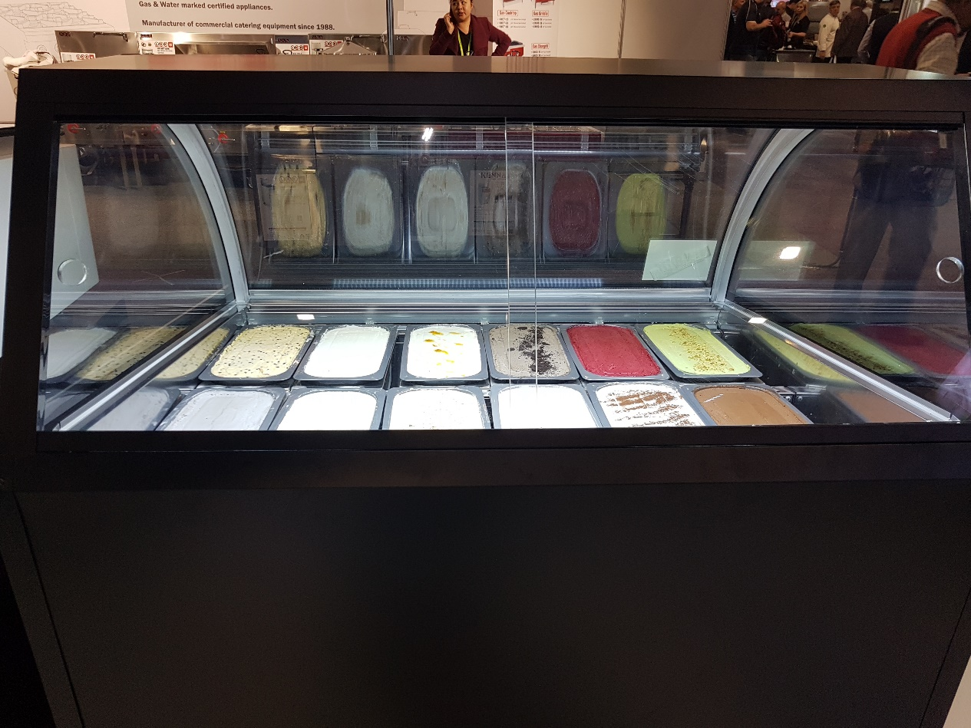

For any assistance or queries, please call your unit’s provider or please call us directly on,

NSW, QLD, ACT, WA, NT customers,

Phone: 02 8798 5061
Email: admin@skipio-australia.com

VIC, SA, TAS customers,

Phone: 03 8405 3359
Email: adminvic@skipio-australia.com

